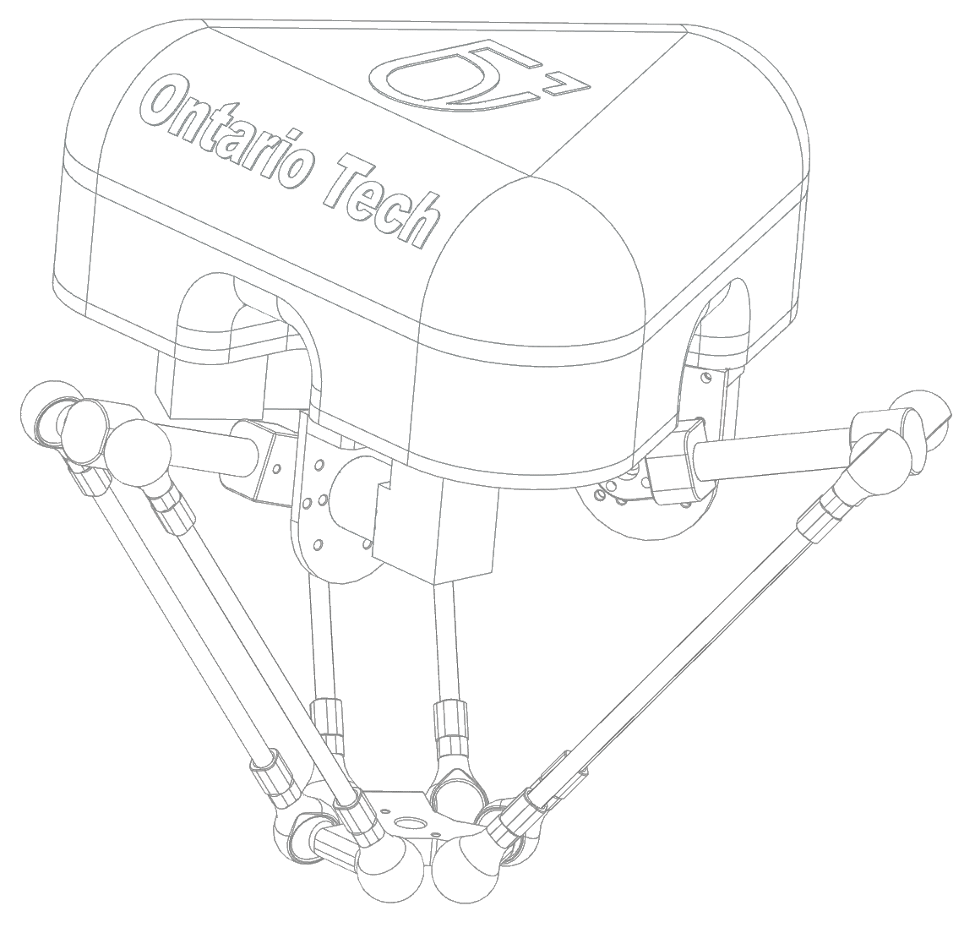

**USER MANUAL**

Parallel Robot for Manipulation

**CONTENTS**

SAFETY 4

1. Attention 4

1.1 Legend 4

2. Safety Information 4

2.1 Delivery 4

2.2 Instillation 4

2.3 Maintenance 5

2.4 Optional Parts 5

OVERVIEW 6

1. Introduction 6

1.1 Description 6

2. Part Names 6

3. Model Renders 7

INSTALLATION 8

1. Delivery 8

2. Unpacking 8

2.1 Parts 8

2.2 Fasteners and Cables 8

3. Assembly 9

3. Assembly Continued 10

4. Mounting 11

5. Calibration 11

MAINTENANCE 12

1. Periodic 12

2. Cleaning 12

3. Replacement and Spare Parts 12

ROBOT SETTINGS 13

1. Kinematics 13

2. Workspace 14

3. Software 14

SPECIFICATIONS 15

1. Basic 15

2. Design 15

# SAFETY

**1**

## 1. Attention

Users of the DELTA ROBOT must follow the instructions outlined in the USER MANUAL, and follow all safety guidelines delineated in the SAFETY SECTION as well as national or regional work safety regulations.

### C:\Users\100616824\AppData\Local\Microsoft\Windows\INetCache\Content.MSO\C0BB3975.tmp1.1 Legend

WARNING: Indicates a potentially dangerous situation



EXTRA INFORMATION: Indicates a point that may require addition knowledge

## 2. Safety Information

The safety section of this manual describes

### 2.1 Delivery

The robot must be transported in the predetermined position. Transportation must follow all guidelines outlined.



WARNING

* Only use equipment that has sufficient load bearing capacity
* Wear protective clothing if required

### 2.2 Instillation

Before Attempting instillation, systems and devices must be checked to ensure they are operational. These checks must be completed to ensure that the robot has not sustained any damage during delivery.

All fasteners must be installed with accordance to specifications and regulations.

All safety equipment must be properly installed and operational.



WARNING

* An incorrect instillation of the robot may lead to serious injury or death

### 2.3 Maintenance

The purpose of maintenance and repair work is to ensure the robot is working correctly and or replace and repair any known damage parts.

During maintenance and repair work the emergency stop must remain active. The surrounding workspace must also be clearly marked as under repair.

### 2.4 Optional Parts

All optional parts and accessories must be treated by the same health and safety regulations as all non-optional parts.

# OVERVIEW

**2**

## 1. Introduction

### 1.1 Description

The parallel manipulator is designed to serve multiple industries through the implantation of pick and place techniques by attaching a gripper mechanism to the end effector. A payload of up to 3kg can be sustained by the robot while maintaining high accuracy and repeatability. The robot leverages state of the art carbon fiber linkages as well as advancements in motor technologies to be used in the most demanding industry tasks.

Features of the robot:

* 3 Degrees of Freedom
* Compact Lightweight design
* 3kg payload

## 2. Part Names

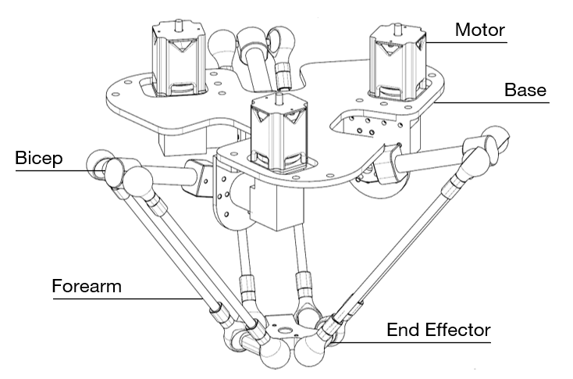



INFORMATION

* Only major parts are labeled, comprehensive parts list for repair can be provided upon request

## 3. Model Renders

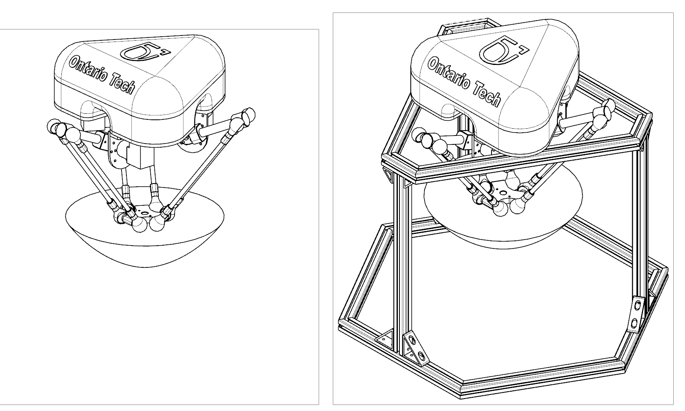

Render including workspace and enclosure.



Render including optional test frame and enclosure.

# INSTALLATION

**3**

## 1. Delivery



## 2. Unpacking

### 2.1 Parts

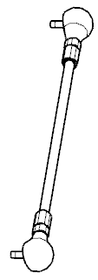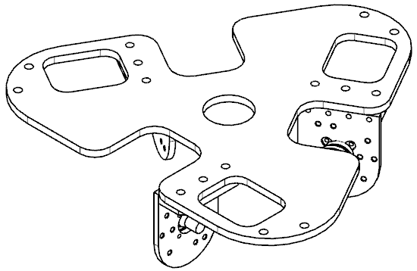

**×6**

**×1**

**×1**

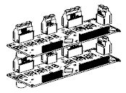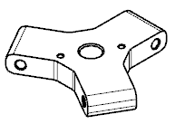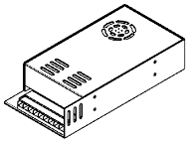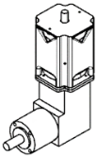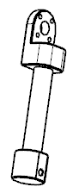

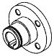

**×1**

**×1**

**×3**

**×3**

**×1**

**×3**

### 2.2 Fasteners and Cables

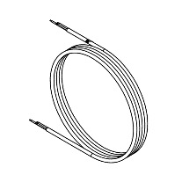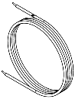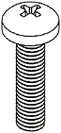

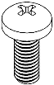

**×6**

**×3**

**×8**

**×3**

**×12**

**×12**

## 3. Assembly

**1**

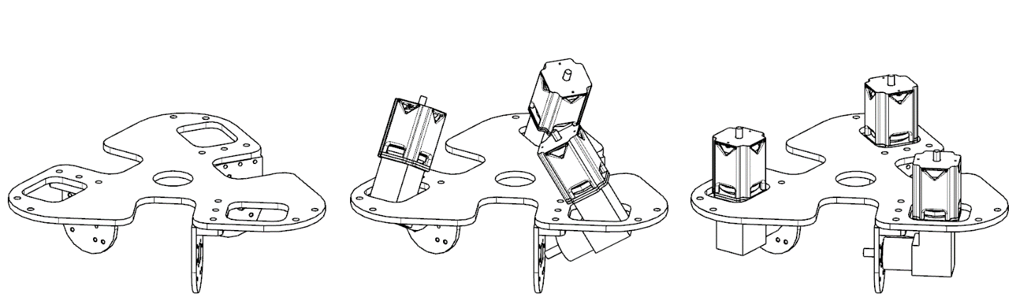

**3**

**2**

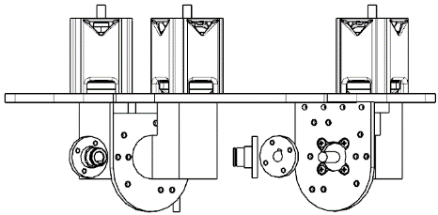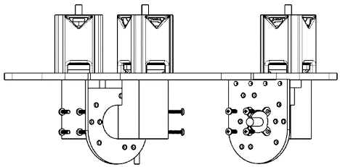



**×12**

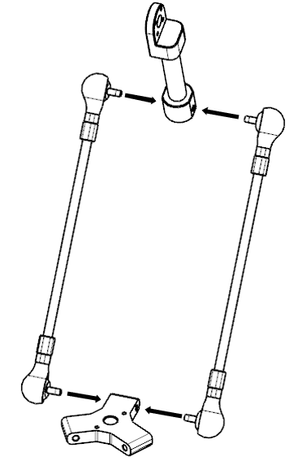

**5**

**4**

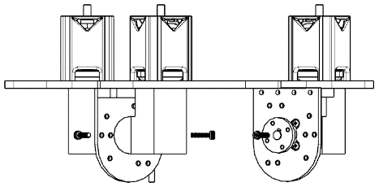



**×3**

## 3. Assembly Continued

**×12**

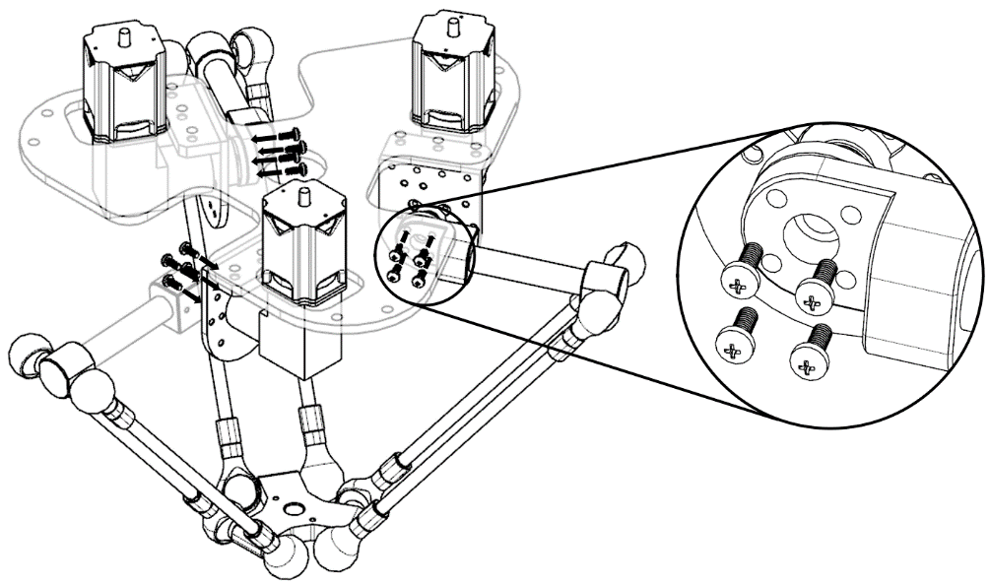

**6**

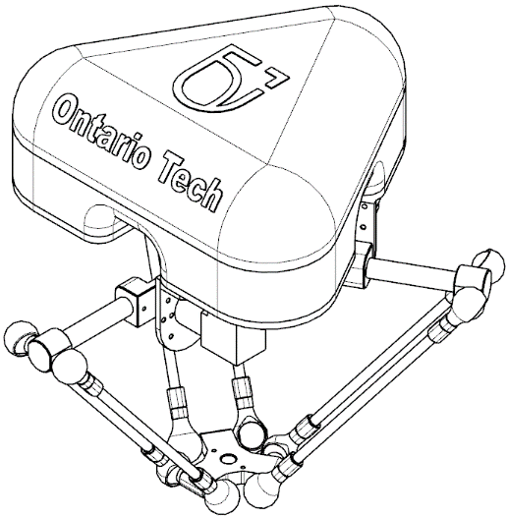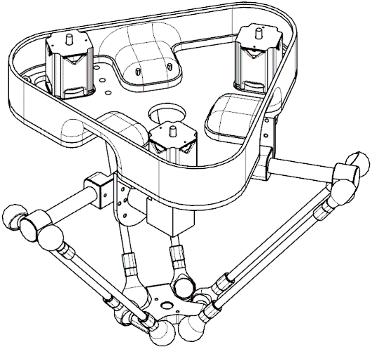

**7**

**8**

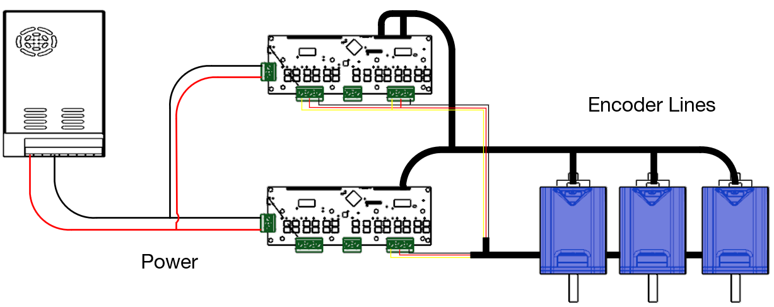



WARNING

* An incorrect instillation of the robot may lead to serious injury or death
* Parts and equipment are heavy and multiple personal are need for instillation process

## 4. Mounting

Mounting holes indicated by the arrows are sized for M8 Bolts. Recognize no mounting hardware is provided and the solution is to be determined by the user. The plate is designed to be used in many common configurations.

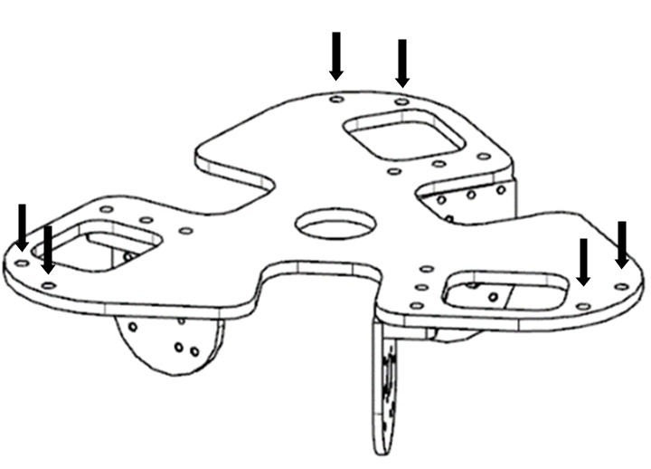



WARNING

* Parts and equipment are heavy and multiple personal are need for mounting process

## 5. Calibration

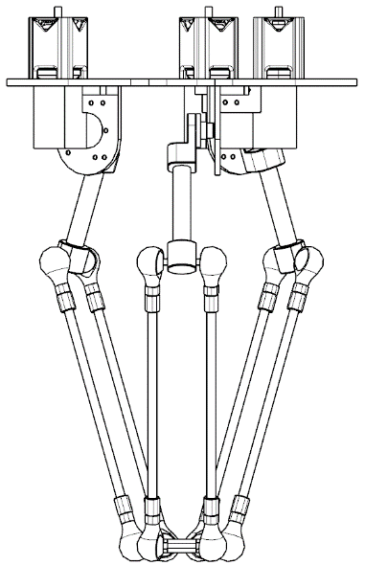The Calibration Sequence is initiated the calibration file ‘Calibration.exe’. The process must be started from the unpowered rest position, and through basic movements and a 90-degree rotation the robot will be brought to its operating base position.

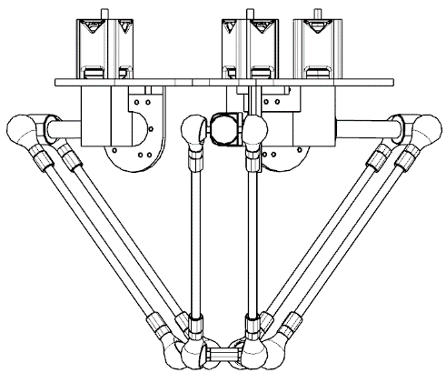

Unpowered Rest Position

Operating Base Position

# MAINTENANCE

**4**

## 1. Periodic

The Robot must be checked periodically to determine or discover any faulty parts, this process will ensure smooth operation and prevent any further damages to the unit.

## 2. Cleaning

The Robot can be cleaned by lightly washing it using a sponge or cloth. The use of soap with water is permitted if followed by a clean water rinse. For stains the use of alcohol on a clean soft cloth is permitted.



WARNING

* The use of any high-pressure cleaning solution may result in mechanical or electrical failure

## 3. Replacement and Spare Parts





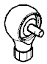

|  |  |
| --- | --- |
| **Number** | **Description** |
| 1 | Ball Joint |
| 2 | Ball Joint Holder |
| 3 | Bicep Arm |
| 4 | Forearm |
| 5 | Gearbox |
| 6 | Motor |
| 7 | Motor Shaft Mount |

# ROBOT SETTINGS

**5**

## 1. Kinematics

There are 3 arms and each arm consist of 2 links, 2 joints and 1 end effector to connect each arm. The end effectors workspace is dependent on the structural composition of the frame and the method of motor mounting.

This is a 3DOF robot with three 3 joints attached to an end effector displaying movement in X Y and Z directions. Each of the joints consist of a bicep, a forearm and multiple ball joints where they all move relative to the actuators. The joint setup shown has a bicep less than the forearm would resulting in a gear reducer, which in turn increases torque and reduces speed.



## 2. Workspace

The results produced from the kinematics are defined by a circular diameter of 210 mm and a height movement of 180mm seen in the figure.

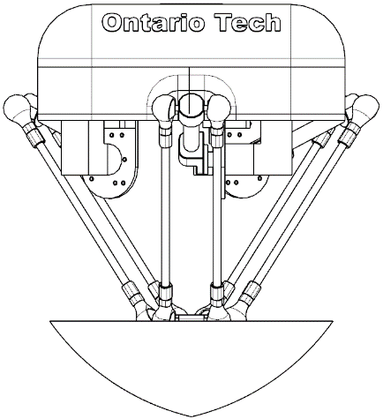

## 3. Software

The robot is able to function through software control, a variety of functions can be called from terminal commands. The commands can be found in the software control manual along with an in-depth instruction set detailing common applications and functions.

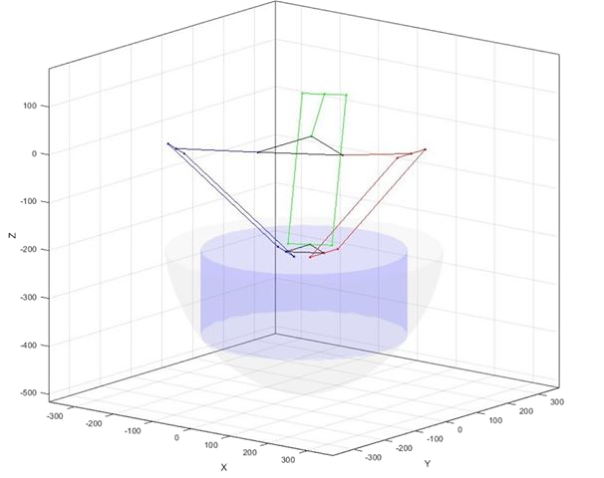

# SPECIFICATIONS

**6**

## 1. Basic

* 3 Degrees of Freedom
* Compact Lightweight design
* 3kg payload
* +/- 0.05 Repeatability

## 2. Design

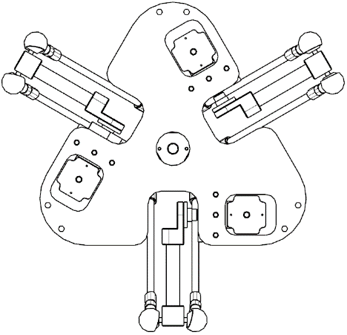

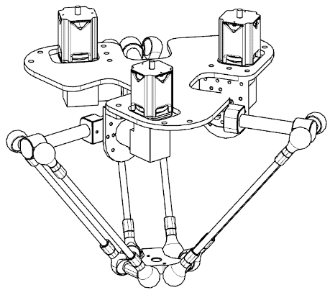

Isometric

Side

Top

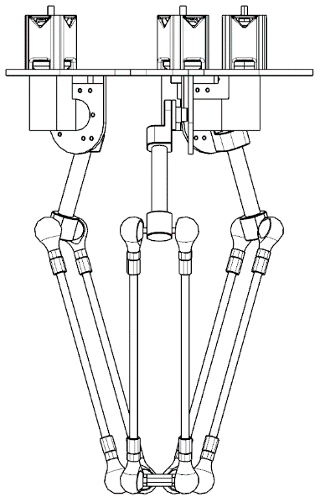

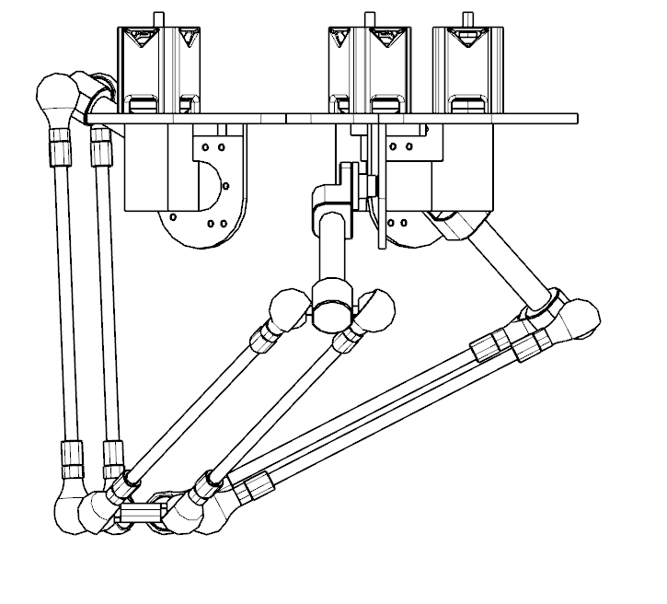

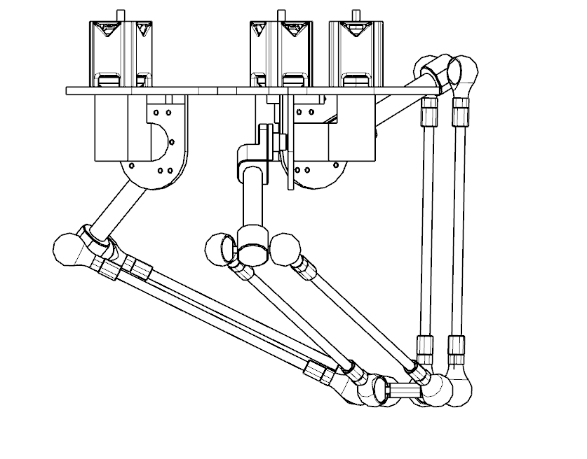

Side (Left)

Side (Right)

Side (Down)